**PRACTICAL - 1**

**AIM**

**Write a program to store roll numbers of student in array who attended training program in random order. Write function for**

**a) Searching whether particular student attended training program or not using linear search and sentinel search.**

**b) Searching whether particular student attended training program or not using binary search and Fibonacci search.**

**PROGRAM CODE**

1. **LINEAR SEARCH**

#include<stdio.h>

#include<conio.h>

void main()

{

int arr[10];

int i;

printf("Enter an array: ");

for(i=0;i<5;i++)

{

scanf("%d",&arr[i]);

}

printf("Array is: ");

for(i=0;i<5;i++)

{

printf("%d ",arr[i]);

}

int j;

printf("\n Enter Number to find: ");

scanf("%d",&j);

int count=0;

for( i=0;i<5;i++)

{

if(j==arr[i])

{

count++;

}

}

if(count==0)

{

printf("\nNumber not found");

}

else

{

printf("\nitem found");

}

}

1. SENTINEL SEARCH

#include<stdio.h>

#include<conio.h>

void main()

{

int arr[5];

int i;

printf("Enter an array: ");

for(i=0;i<5;i++)

{

scanf("%d",&arr[i]);

}

for(i=0;i<5;i++)

{

printf("%d ",arr[i]);

}

int last=arr[4];

int j;

printf("\nEnter Number to find: ");

scanf("%d",&j);

arr[4]=j;

int count=0;

while(arr[i]=!arr[4])

{

i++;

}

if(i<4 || last==arr[4])

{

printf("Number found");

}

else

{

printf("Number not found");

}

}

1. BINARY SEARCH

#include<stdio.h>

#include<conio.h>

void main()

{

int arr[10];

int i;

printf("Enter an array");

for(i=0;i<10;i++)

{

scanf("%d",&arr[i]);

}

for(i=0;i<10;i++)

{

printf("%d",arr[i]);

}

int mid;

int lb=0;

int ub=9;

int num;

printf("\n Enter no. to find");

scanf("%d",&num);

while(lb<=ub)

{

mid=(lb+ub)/2;

if(arr[mid]==num)

{

printf("\n item matched");

break;

}

else if(num<arr[mid])

{

ub=mid-1;

}

else

{

lb=mid+1;

}

printf("\n item not matched");

}

}

**OUTPUT**

LINEAR SEARCH

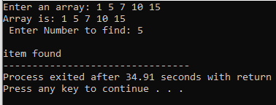

SENTINEL SEARCH

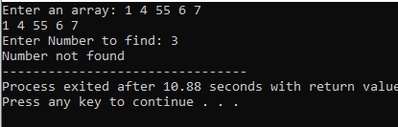

BINARY SEARCH

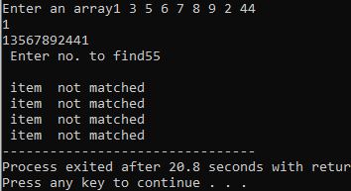

**CONCLUSION**

In this practical we learned about types of search

(1)linear search or sentinel search

(2)binary search.

**PRACTICAL - 2**

**AIM**

**Mark purchased Books from books store of standard 1 to 7. He purchased 4 books for each standard(for std.1 books are 1.1,1.2,1.3,1.4 and for std. 2 books are 2.1,2.2,2.3,2.4 and so on..). When he reached home, he opens the bag and sees that all the books got mixed. So, how he will sort all the books, according to the standards and their preference in that particular standard. (ex. : preference in std. 1 is 1.1<1.2<1.3**

**2.1: SELECTION SORT that arranges in descending order**

**2.2: INSERTION SORT that arranges in ascending order**

**PROGRAM CODE**

**2.1 SELECTION SORT**

import java.util.*;

class sel{

public static void main(String[] args) {

Scanner s=new Scanner(System.in);

int min=0,index=0,temp=0;

int arr[]=new int[5];

for (int i=0;i<5 ;++i ) {

arr[i]=s.nextInt();

}

for(int i=0;i<5;++i){

min=i;

for (int j=i+1;j<5 ;++j ) {

if(arr[j]<arr[min]){

min=j;

}

}

temp=arr[i];

arr[i]=arr[min];

arr[min]=temp;

}

for(int i=0;i<5;++i){

System.out.print(arr[i]+" ");

}

}

}

**OUTPUT**

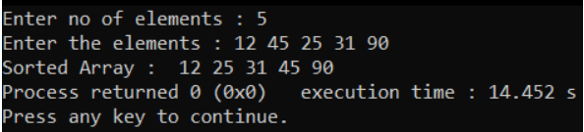

**PROGRAM CODE**

2.2 INSERTION SORT

#include<iostream>

using namespace std;

int main()

{

int a[30],i,j,key,n;

cout<<"Enter no of elements : ";

cin>>n;

cout<<"Enter the elements : ";

for(int i =0;i<n;i++)

cin>>a[i];

for(int i =1;i<n;i++)

{

int key = a[i];

int j=i-1;

while((j>=0)&&(a[j]>key))

{

a[j+1]=a[j];

j=j-1;

}

a[j+1]=key;

}

cout<<"Sorted Array : ";

for(int i =0;i<n;i++)

cout<<" "<<a[i];

}

**OUTPUT**

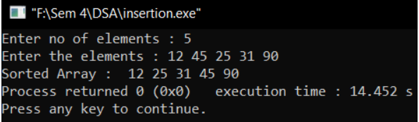

**CONCLUSION**

By this practical, we learned two sorting algorithms : Selection sort & Insertion sort.

**PRACTICAL - 3**

**AIM**

**Implement a menu driven program that performs following sorting algorithms**

**3.1 QUICK SORT that arranges in ascending order**

**3.2 MERGE SORT that arranges in descending order**

**PROGRAM CODE**

**3.1 QUICK SORT**

#include<iostream>

using namespace std;

void swapping(int &a, int &b)

{

int temp;

temp = a;

a = b;

b = temp;

}

void display(int *array, int size) {

for(int i = 0; i<size; i++)

cout<< array[i] << " ";

cout<<endl;

}

int partition(int *array, int lower, int upper)

{

int pivot, start, end;

pivot = array[lower];

start = lower; end = upper;

while(start < end) {

while(array[start] <= pivot && start<end)

{

start++;

}

while(array[end] > pivot) {

end--;

}

if(start < end) {

swap(array[start], array[end]);

}

}

array[lower] = array[end];

array[end] = pivot;

return end;

}

void quickSort(int *array, int left, int right) {

int q;

if(left < right) {

q = partition(array, left, right);

quickSort(array, left, q-1);

quickSort(array, q+1, right);

}

}

int main() {

int n;

cout<< "Enter the number of elements: ";

cin>> n;

int arr[n];

cout<< "Enter elements:" <<endl;

for(int i = 0; i<n; i++) {

cin>>arr[i];

}

quickSort(arr, 0, n-1);

cout<< "Array after Sorting: "<<endl;

display(arr, n);

}

**OUTPUT**

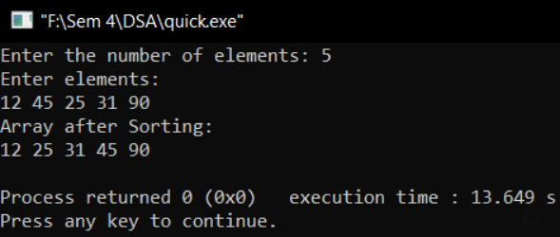

**PROGRAM CODE**

**3.2 MERGE SORT**

#include<iostream>

using namespace std;

void Merge(int *a,intlow,intub,int mid)

{

int i,j,k,b[ub-low+1];

i=low;

k=0;

j=mid+1;

while(i<=mid && j<=ub)

{

if(a[i]>a[j])

{

b[k]=a[i];

k++;

i++;

}

else

{

b[k]=a[j];

k++;

j++;

}

}

while(i<=mid)

{

b[k]=a[i];

k++;

i++;

}

while(j<=ub)

{

b[k]=a[j];

k++;

j++;

}

for(i=low;i<=ub;i++)

{

a[i]=b[i-low];

}

}

void MergeSort(int *a,intlow,intub)

{

int mid;

if(low<ub)

{

mid=(low+ub)/2;

MergeSort(a,low,mid);

MergeSort(a,mid+1,ub);

Merge(a,low,ub,mid);

}

}

int main()

{

int i,n;

cout<<"\nEnter the number of data elements to be sorted :";

cin>>n;

int a[n];

for(i=0;i<n;i++)

{

cout<<"Enter the element "<<i+1<<": ";

cin>>a[i];

}

MergeSort(a, 0, n-1);

cout<<"\nSorted Data : ";

for (i = 0; i< n; i++)

cout<<" "<<a[i];

return 0;

}

**OUTPUT**

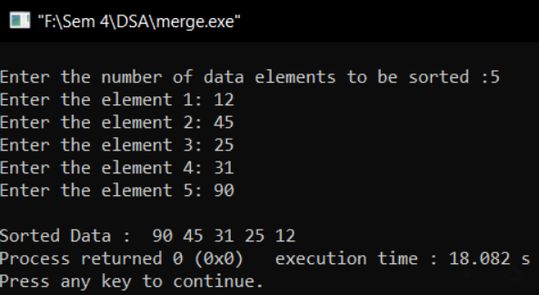

**CONCLUSION**

By this practical, we learned two sorting algorithms : Quick sort and Merge sort.

**PRACTICAL - 4**

**AIM**

**Perform following programs using Stack data structure:**

**4.1 Sometimes a program requires two stack containing the same type of items. If the two stacks are stored in separate arrays. Then one stack might overflow while there was considerable unused space in the other. A neat way to avoid the problem is to put all the space in one array and let one stack grow from one end of the array and the other stack start at the other end and grow in opposite direction i.e., toward the first stack, in this way, if one stack turns out to be large and the other small, then they will still both fit, and there will be no overflow until all the space is actually used. Declare a new structure type Double stack that includes the array and the two indices top A and top B, and write functions Push A, Push B, Pop A and Pop B to handle the two stacks with in one Double Stack.**

**4.2 Implement Tower of Hanoi Problem using Recursion.**

**PROGRAM CODE**

**4.1 USING STACK**

#include<iostream>

#include<stack>

using namespace std;

int main()

{

stack<int>mys;

mys.push(10);

mys.push(3);

mys.push(5);

mys.push(9);

mys.push(1);

mys.pop();

mys.pop();

while(!mys.empty())

{

cout<<" "<<mys.top();

mys.pop();

}

}

**OUTPUT**

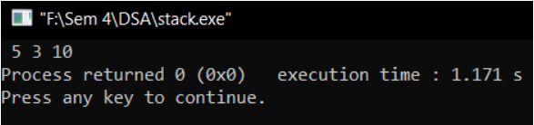

**PROGRAM CODE**

4.1 USING QUEUE

#include<iostream>

#include<queue>

using namespace std;

int main()

{

queue<int>myq;

myq.push(10);

myq.push(3);

myq.push(5);

myq.push(9);

myq.push(1);

myq.pop();

myq.pop();

while(!myq.empty())

{

cout<<" "<<myq.front();

myq.pop();

}

}

**OUTPUT**

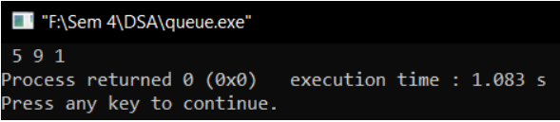

**PROGRAM CODE**

4.2 TOWER OF HANOI

#include<iostream>

using namespace std;

void towerOfHanoi(int n, char beg,charaux,charendi)

{

if(n==1)

{

cout<<"Move disk 1 from rod "<<beg<<" to rod "<<aux<<endl;

return;

}

towerOfHanoi(n-1,beg,endi,aux);

cout<<"Move disk "<<n<<" from rod "<<beg<<" to rod "<<endi<<endl;

towerOfHanoi(n-1,endi,aux,beg);

}

int main()

{

int n;

cout<<"Enter the no. of disks :";

cin>>n;

towerOfHanoi(n,'A','C','B');

return 0;

}

**OUTPUT**

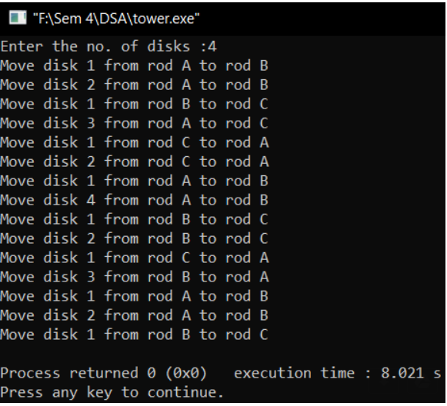

**CONCLUSION**

By this practical, we learned how to implement stack, queue and tower of Hanoi.

**PRACTICAL - 5**

**AIM**

**We are developing software for a call centre. When a client calls, his/her call should be stored until there is a free service representative to pick the call. Calls should be processed in the same order they are received. Select appropriate data structure to build call centre software system.**

**PROGRAM CODE**

**USING QUEUE**

import java.util.*;

class qu

{int ar[]=new int[5]; int fr=0,re=0,max=5; void ins(int in){

if(re+1 == max-1)

{

System.out.println(" OVERFLOW !!!");

}

else

{

ar[re]=in;

re++;

}

}

void del()

{

if(fr == re)

{

System.out.println(" UNDERFLOW !!!");

}

else

{fr++;

System.out.println("Call processed successfully!");}

}

public static void main(String ar[])

{

Scanner s=new Scanner(System.in); qu q1=new qu();

char q; do

{

System.out.println("1. INSERT\n2. DELETE\n"); System.out.print("Enter choice: ");

int c=s.nextInt(); switch(c){ case 1:

System.out.print("Enter call to store: "); int i=s.nextInt();

q1.ins(i);

break;

case 2:

q1.del();

break;

}

System.out.print("Do you want to continue?[y/n] : "); q=s.next().charAt(0);

}

while(q=='y');

}

}

**OUTPUT**

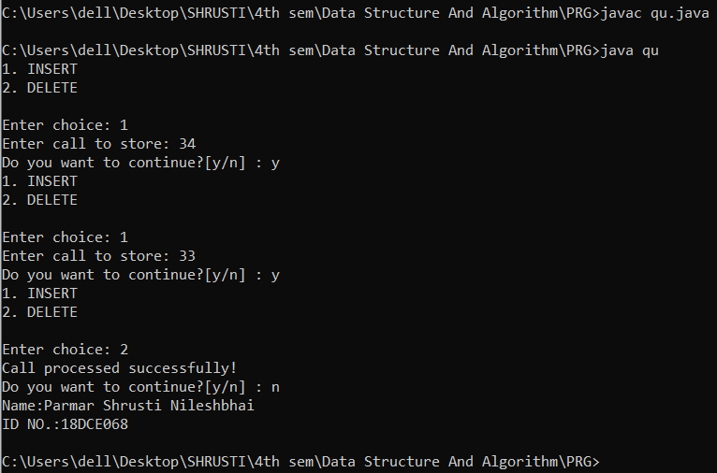

**CONCLUSION**

In this practical we have implemented queue using array.

**PRACTICAL - 6**

**AIM**

**Department of Computer Engineering has student's club named 'Pinnacle Club'. Students of Second, third and final year of department can be granted membership on request. Similarly, one may cancel the membership of club. First node is reserved for president of club and last node is reserved for secretary of club. Write a program to maintain club member ‘s information using singly linked list. Store student PRN and Name. Write functions to**

**a) Add and delete the members as well as president or even secretary.**

**b) Compute total number of members of club**

**c) Display members**

**d) Display list in reverse order using recursion**

**e) Two linked lists exists for two divisions. Concatenate two lists.**

**PROGRAM CODE**

#include <iostream>

#include <string.h>

using namespace std;

//Node

struct node {

int prn;

string name;

struct node *next;

};

//Linked List

class list {

node *head, *temp;

public:

list() {

head = NULL;

}

node *create(int val, string n);

void insertEnd();

void insertBeg();

void deleteAt(int i);

void insertAt(int i);

void display();

int count();

void reverse();

void rev(node *t);

node* readAt(int i);

void concatenate(list A,list B);

void op();

};

//Create

node* list::create(int val, string n) {

temp = new(struct node);

if (temp == NULL) {

cout<<"Memory Allocation Failed!"<<endl;

return 0;

} else {

temp -> prn = val;

temp -> name = n;

temp -> next = NULL;

return temp;

}

}

//Insert End

void list::insertEnd() {

int val;

string n;

cout<<"Enter PRN: ";

cin>>val;

cout<<"Enter Name: ";

cin>>n;

struct node *t = head;

temp = create(val,n);

if (head == NULL) {

head = temp;

head -> next = NULL;

} else {

while ((t -> next) != NULL) {

t = t -> next;

}

temp -> next = NULL;

t -> next = temp;

cout<<"Element Inserted at Last"<<endl;

}

}

//Insert At

void list::insertAt(int i) {

int val,pos = i - 1,counter = 1;

string n;

struct node *ptr;

struct node *t = head;

while ((t -> next) != NULL) { //loop to count number of items in linked list.

t = t -> next;

counter++;

}

t = head; //traverse pointer is pointed to head again.

if (i == 1) { //equivalent to insert at start.

insertBeg();

} else if (pos > counter || i <= 0) { //if position is greater than the actual linked list.

cout<<"Entered position is out of scope."<<endl;

} else { //insert at required position.

cout<<"Enter PRN: ";

cin>>val;

cout<<"Enter Name: ";

cin>>n;

temp = create(val,n);

while (pos--) {

ptr = t;

t = t -> next;

}

temp -> next = t;

ptr -> next = temp;

cout<<"Member Inserted at Position: "<<i<<endl;

}

}

//Delete At

void list::deleteAt(int i) {

int val,pos = i - 1,counter = 1;

string n;

struct node *ptrl,*ptrr;

struct node *t = head;

while ((t -> next) != NULL) {

t = t -> next;

counter++;

}

t = head;

if (i == 1) {

ptrl = head;

head = head -> next;

delete ptrl;

} else if (pos > counter || i <= 0) {

cout<<"Entered member doesn't exist."<<endl;

} else {

while (pos--) {

ptrl = t;

t = t -> next;

ptrr = t -> next;

}

ptrl -> next = ptrr;

delete t;

cout<<"Member Deleted at Position: "<<i<<endl;

}

}

//Insert Beg

void list::insertBeg() {

int val;

string n;

cout<<"Enter PRN: ";

cin>>val;

cout<<"Enter Name: ";

cin>>n;

//v = val;

struct node *t = head;

temp = create(val,n);

if (head == NULL) {

head = temp;

head -> next = NULL;

} else {

temp -> next = head;

head = temp;

cout<<"We have a New President."<<endl;

}

}

//Display

void list::display() {

temp = head;

cout<<"President: ";

cout<< temp -> prn<<" — "<<temp -> name<<" -> ";

if(temp -> next != NULL) {

temp = temp -> next;

}

while (temp -> next != NULL) {

cout<< temp -> prn<<" — "<<temp -> name<<" -> ";

temp = temp -> next;

}

cout<<"Secretary: ";

cout<< temp -> prn<<" — "<<temp -> name<<" -> ";

cout<<"NULL"<<endl;

}

//Count

int list::count() {

temp = head;

int ct = 0;

while (temp != NULL) {

ct++;

temp = temp -> next;

}

return ct;

}

//Concatenate

void list::concatenate(list A,list B) {

struct node * last,*last1;

node* t = A.head;

while (t != NULL) {

int val = t -> prn;

string n = t -> name;

temp = create(val,n);

if (head == NULL) {

head = temp;

head -> next = NULL;

last=head;

} else {

//temp -> next = NULL;

last -> next = t;

last=t;

}

t = t -> next;

}

last -> next = B.head;

t = B.head;

while (t != NULL) {

int val = t -> prn;

string n = t -> name;

temp = create(val,n);

last -> next = temp;

last= temp;

t = t -> next;

}

last->next=NULL;

}

//Accept

void list::op() {

while(1) {

int choice;

cout<<"\nEnter: \n1. Add \n2. Delete \n3. Member's Count \n4. Display \n5. Reverse the List \n0. Prev Menu"<<endl;

cin>>choice;

switch(choice) {

case 1: { //Add

char c;

cout<<"\nEnter: \nA. Add President \nB. Add Secretary \nC. Add Member"<<endl;

cin>>c;

switch(c) {

case 'A':

case 'a':{

insertBeg();

break;

}

case 'B':

case 'b': {

insertEnd();

break;

}

case 'C':

case 'c': {

insertAt(2);

break;

}

}

break;

}

case 2: { //Delete

char c;

cout<<"\nEnter: \nA. Delete President \nB. Delete Secretary \nC. Delete Member"<<endl;

cin>>c;

switch(c) {

case 'A': {

deleteAt(1);

cout<<"Club must have a President. Enter Details"<<endl;

insertBeg();

break;

}

case 'B': {

deleteAt(count());

cout<<"Club must have a Secretary. Enter Details"<<endl;

insertEnd();

break;

}

case 'C': {

int j;

cout<<"Enter Position for Deletion"<<endl;

cin>>j;

deleteAt(j);

break;

}

}

break;

}

case 3: { //Count

cout<<"Count: "<<count()<<endl;

break;

}

case 4: { //Display

if (head == NULL) {

cout<<"NULL"<<endl;

break;

} else {

display();

break;

}

}

case 5: { //Reverse

reverse();

break;

}

case 0: { //Prev Menu

return;

}

}

}

}

//Reverse Recursion

void list::rev(node *t) {

if(t -> next != NULL) {

rev (t -> next);

}

if(t == head)

cout<<"Secretary: "<<t -> prn<<" — "<<t -> name<<endl;

else if(t -> next == NULL)

cout<<"President: "<<t -> prn<<" — "<<t -> name<<" -> ";

else

cout<<"Member: "<<t -> prn<<" — "<<t -> name<<" -> ";

}

//Reverse

void list::reverse() {

rev(head);

}

//Read At

node* list::readAt(int i) {

struct node *t = head;

int c = count();

while(c--) {

t = t-> next;

}

}

//Main

int main() {

list L,X,Y;

int c;

while(1) {

cout<<"Enter: \n1. List A \n2. List B \n3. Concatenate\n0. Exit"<<endl;

cin>>c;

switch(c) {

case 1: cout<<"\nList A:"; X.op(); break;

case 2: cout<<"\nList B:"; Y.op(); break;

case 3: L.concatenate(X,Y); L.display(); break;

case 0: return 0;

}

}

}

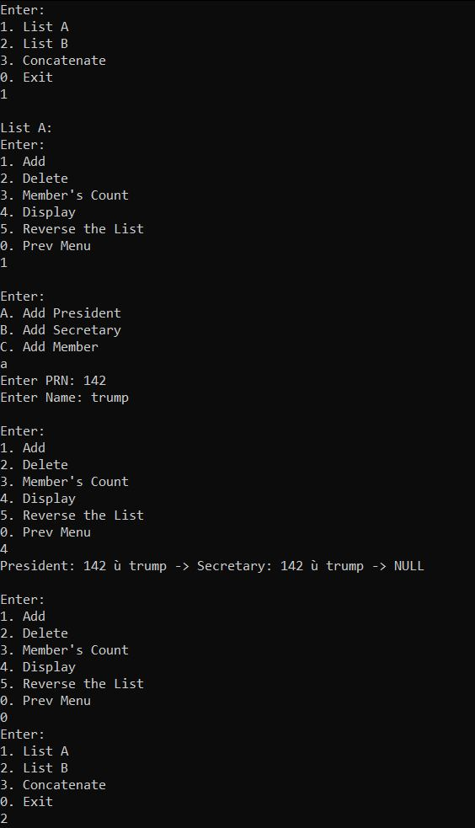 **OUTPUT**

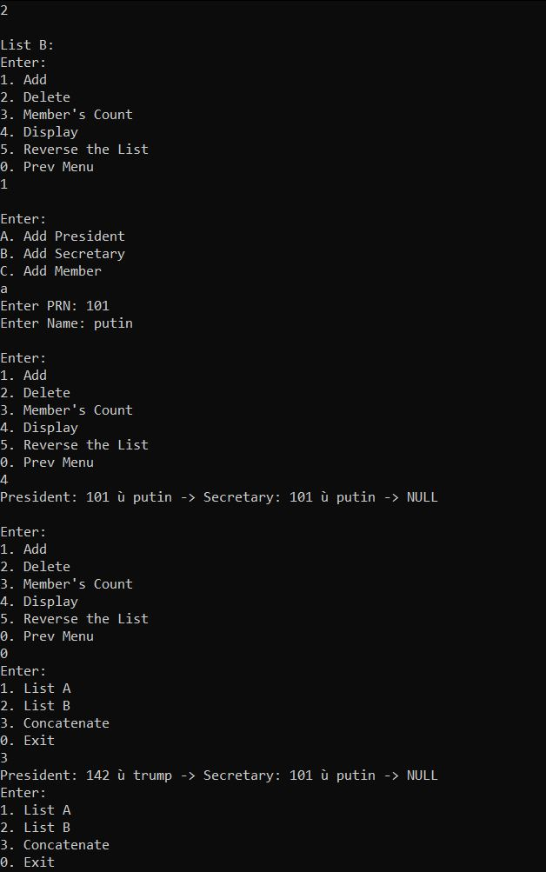

**CONCLUSION**

From the above practical, we have learnt how to do insert , delete and display operation in it and to display list in reverse order using recursion. Also learnt how concatenate two linked lists.

**PRACTICAL - 7**

**AIM**

**Write a program to implement Circular Queue with all operations. Check the queue contents and conditions with different combinations of insert and delete operations. Show the content of circular queue with front and rear pointer after each operation. Initially, the queue is empty. The size of the queue is 5. The sequence of operation given below:**

* **Insert 10, 50, 40, 80**
* **Delete**
* **Insert 200, 70, 150**
* **Delete**
* **Delete**
* **Delete**

**PROGRAM CODE**

import java.io.*;

public class Circular_Queue{

int Q[] = new int[100];

int n, front, rear;

static BufferedReader br = new BufferedReader(new InputStreamReader(System.in));

public Circular_Queue(int nn){

n=nn;

front = rear = 0;

}

public void add(int v){

if((rear+1) % n != front){

rear = (rear+1)%n;

Q[rear] = v;

}

else

System.out.println("Queue is full !");

}

public int del(){

int v;

if(front!=rear){

front = (front+1)%n;

v = Q[front];

return v;

}

else

return -9999;

}

public void disp(){

int i;

if(front != rear){

i = (front +1) %n;

while(i!=rear){

System.out.println(Q[i]);

i = (i+1) % n;

}

}

else

System.out.println("Queue is empty !");

}

public static void main(String args[]) throws IOException{

System.out.print("Enter the size of the queue : ");

int size = Integer.parseInt(br.readLine());

Circular_Queue call = new Circular_Queue(size);

int choice;

boolean exit = false;

while(!exit){

System.out.print("\n1 : Add\n2 : Delete\n3 : Display\n4 : Exit\n\nYour Choice : ");

choice = Integer.parseInt(br.readLine());

switch(choice){

case 1 :

System.out.print("\nEnter number to be added : ");

int num = Integer.parseInt(br.readLine());

call.add(num);

break;

case 2 :

int popped = call.del();

if(popped != -9999)

System.out.println("\nDeleted : " +popped);

else

System.out.println("\nQueue is empty !");

break;

case 3 :

call.disp();

break;

case 4 :

exit = true;

break;

default :

System.out.println("\nWrong Choice !");

break;

}

}

}

}

**OUTPUT**

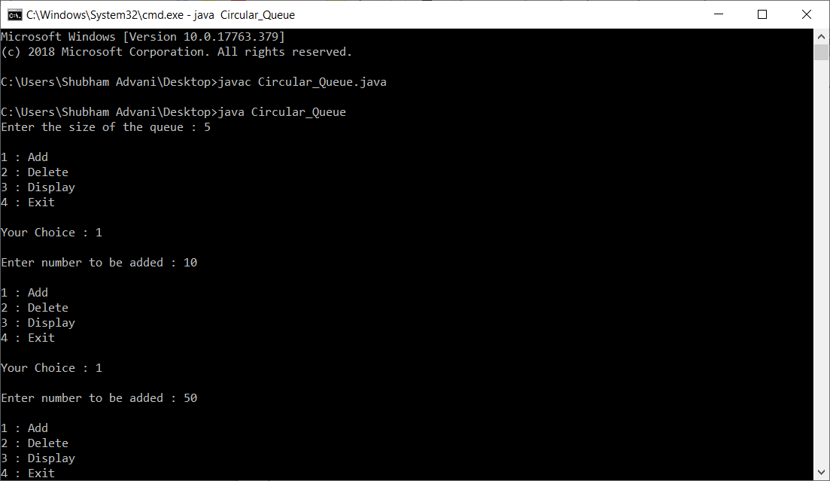

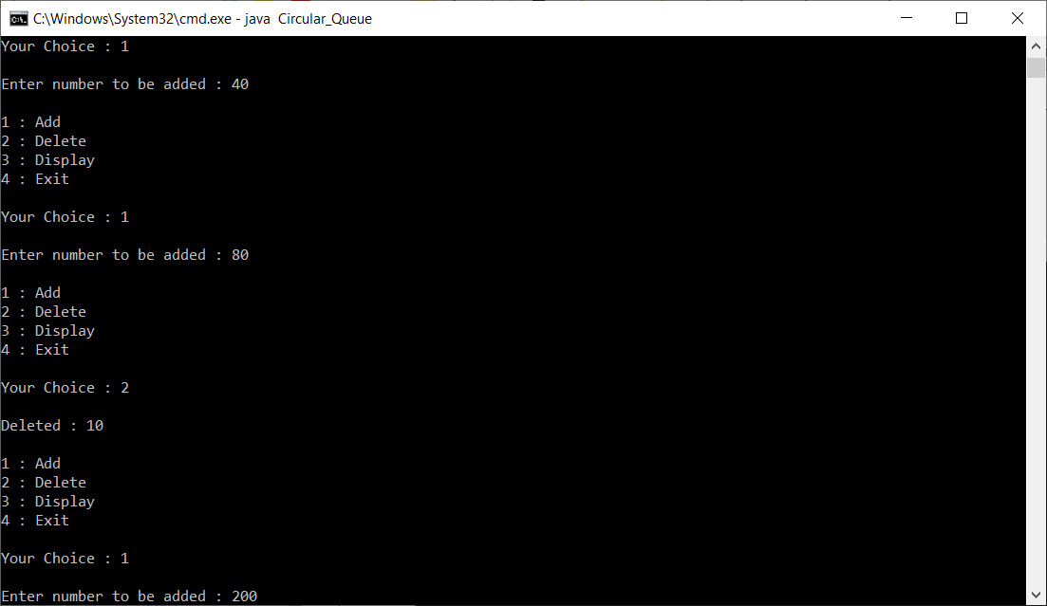

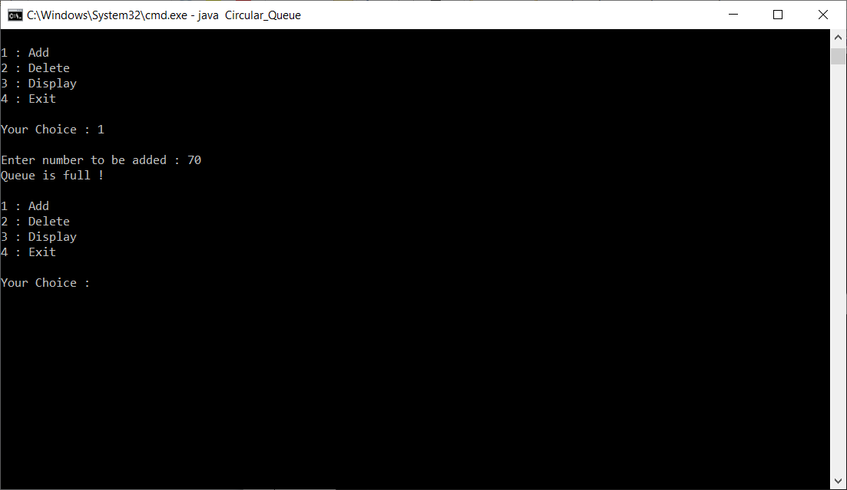

**CONCLUSION**

From the above practical, we learned about circular queue and how to do insert , delete and display operation in it.

**PRACTICAL - 8**

**AIM**

**Implement the program display Linked List in Reverse**

**PROGRAM CODE**

#include <stdio.h>

#include <stdlib.h>

struct node {

int data;

struct node *next;

}*head;

void createList(int n);

void reverseList();

void displayList();

int main()

{

int n, choice;

printf("Enter the total number of nodes: ");

scanf("%d", &n);

createList(n);

printf("\nData in the list \n");

displayList();

printf("\nPress 1 to reverse the order of singly linked list\n");

scanf("%d", &choice);

if(choice == 1)

{

reverseList();

}

printf("\nData in the list\n");

displayList();

return 0;

}

void createList(int n)

{

struct node *newNode, *temp;

int data, i;

if(n <= 0)

{

printf("List size must be greater than zero.\n");

return;

}

head = (struct node *)malloc(sizeof(struct node)); if(head == NULL)

{

printf("Unable to allocate memory.");

}

else

{

printf("Enter the data of node 1: ");

scanf("%d", &data);

head->data = data;

head->next = NULL;

temp = head;

for(i=2; i<=n; i++)

{

newNode = (struct node *)malloc(sizeof(struct node)); if(newNode == NULL)

{

printf("Unable to allocate memory."); break;

}

else

{

printf("Enter the data of node %d: ", i);

scanf("%d", &data);

newNode->data = data;

newNode->next = NULL;

temp->next = newNode;

temp = temp->next;

}

}

printf("SINGLY LINKED LIST CREATED SUCCESSFULLY\n");

}

}

void reverseList()

{

struct node *prevNode, *curNode;

if(head != NULL)

{

prevNode = head;

curNode = head->next;

head = head->next;

prevNode->next = NULL;

while(head != NULL)

{

head = head->next;

curNode->next = prevNode;

prevNode = curNode;

curNode = head;

}

head = prevNode;

printf("SUCCESSFULLY REVERSED LIST\n");

}

}

void displayList()

{

struct node *temp;

if(head == NULL)

{

printf("List is empty.");

}

else

{

temp = head;

while(temp != NULL)

{

printf("Data = %d\n", temp->data);

temp = temp->next;

}

}

}

**OUTPUT**

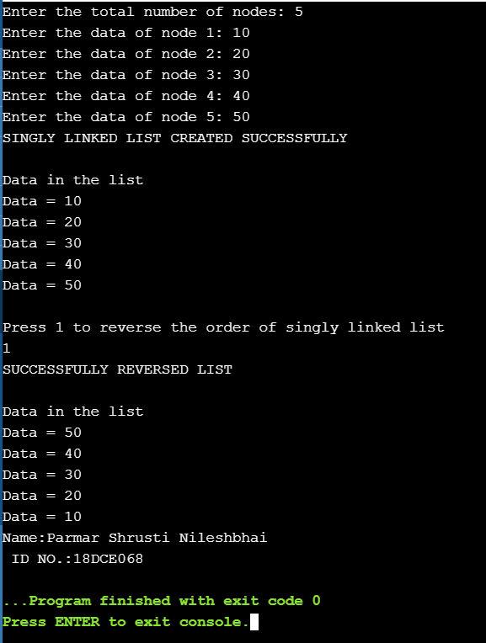

**CONCLUSION**

We have studied about how to access nodes in linked list to reverse side.

**PRACTICAL - 9**

**AIM**

**Implement a city database using a BST to store the database records. Each database record contains the name of the city (a string of arbitrary length) and the coordinates of the city expressed as integer x- and y-coordinates The BST should be organized by city name. Your database should allow records to be inserted, deleted by name or coordinate, and searched by name or coordinate. Another operation that should be supported is to print all records within a given distance of a speciﬁed point. Collect running-time statistics for each operation. Which operations can be implemented reasonably efﬁciently (i.e., inΘ(logn)time in theaverage case) using a BST? Can the database system be made more efﬁcient by using one or more additional BSTs to organize the records by location?**

**PROGRAM CODE**

import java.util.Random;

import java.util.Scanner;

class BSTNode {

BSTNode left, right;

int data;

public BSTNode() {

left = null;

right = null;

data = 0;

}

public BSTNode(int n) {

left = null;

right = null;

data = n;

}

public void setLeft(BSTNode n) {

left = n;

}

public void setRight(BSTNode n) {

right = n;

}

public BSTNode getLeft() {

return left;

}

public BSTNode getRight(){

return right;

}

public void setData(int d) {

data = d;

}

public int getData() {

return data;

}

}

class BST {

private BSTNode root;

public BST() {

root = null;

}

public boolean isEmpty() {

return root == null;

}

public void insert(int data) {

root = insert(root, data);

}

private BSTNode insert(BSTNode node, int data) {

if (node == null)

node = new BSTNode(data);

else {

if (data <= node.getData())

node.left = insert(node.left, data);

else

node.right = insert(node.right, data);

}

return node;

}

public void delete(int k) {

if (isEmpty())

System.out.println("Tree Empty");

else if (search(k) == false)

System.out.println("Sorry " + k + " is not present");

else {

root = delete(root, k);

System.out.println(k + " deleted from the tree");

}

}

private BSTNode delete(BSTNode root, int k) {

BSTNode p, p2, n;

if (root.getData() == k) {

BSTNode lt, rt;

lt = root.getLeft();

rt = root.getRight();

if (lt == null && rt == null)

return null;

else if (lt == null) {

p = rt;

return p;

}

else if (rt == null) {

p = lt;

return p;

}

else {

p2 = rt;

p = rt;

while (p.getLeft() != null)

p = p.getLeft();

p.setLeft(lt);

return p2;

}

}

if (k < root.getData()) {

n = delete(root.getLeft(), k);

root.setLeft(n);

}

else {

n = delete(root.getRight(), k);

root.setRight(n);

}

return root;

}

public int countNodes() {

return countNodes(root);

}

private int countNodes(BSTNode r) {

if (r == null)

return 0;

else {

int l = 1;

l += countNodes(r.getLeft());

l += countNodes(r.getRight());

return l;

}

}

public boolean search(int val) {

return search(root, val);

}

private boolean search(BSTNode r, int val) {

boolean found = false;

while ((r != null) && !found) {

int rval = r.getData();

if (val < rval)

r = r.getLeft();

else if (val > rval)

r = r.getRight();

else {

found = true;

break;

}

found = search(r, val);

}

return found;

}

public void inorder() {

inorder(root);

}

private void inorder(BSTNode r) {

if (r != null) {

inorder(r.getLeft());

System.out.print(r.getData() + " ");

inorder(r.getRight());

}

}

public void preorder() {

preorder(root);

}

private void preorder(BSTNode r) {

if (r != null) {

System.out.print(r.getData() + " ");

preorder(r.getLeft());

preorder(r.getRight());

}

}

public void postorder() {

postorder(root);

}

private void postorder(BSTNode r) {

if (r != null) {

postorder(r.getLeft());

postorder(r.getRight());

System.out.print(r.getData() + " ");

}

}

}

public class Binary_Search_Tree {

public static int N = 20;

public static void main(String args[]) {

Scanner sc = new Scanner(System.in);

BST bst = new BST();

boolean loop=false;

while(!loop){

System.out.println("Enter your choice");

System.out.println("1.Insert\n2.Delete\n3.Search\n4.Exit");

int choice=sc.nextInt();

switch (choice) {

case 1:

System.out.println("Enter the element to be inserted:");

int in=sc.nextInt();

bst.insert(in);

break;

case 2:

System.out.println("Enter the number to be deleted:");

int out=sc.nextInt();

bst.delete(out);

break;

case 3:

System.out.println("Enter the number to be searched:");

int see=sc.nextInt();

System.out.println(bst.search(see));

break;

case 4:

loop=true;

break;

default:

System.out.println("Incorrect Input! Enter again!");

break;

}

}

System.out.println("In order traversal of the tree :");

bst.inorder();

System.out.println();

System.out.println("Post order traversal of the tree :");

bst.postorder();

System.out.println();

System.out.println("Pre order traversal of the tree :");

bst.preorder();

sc.close();

}

}

**OUTPUT**

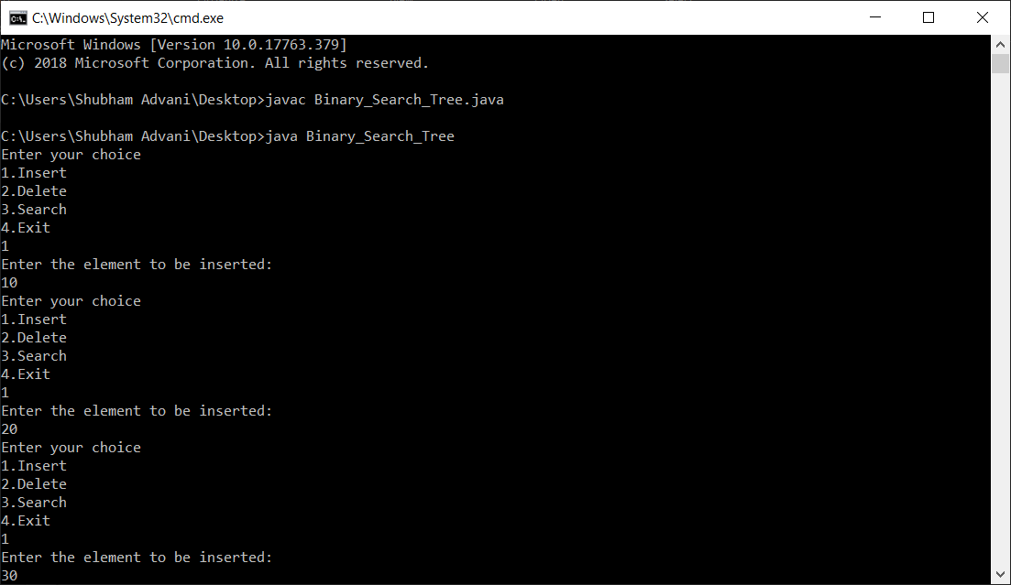

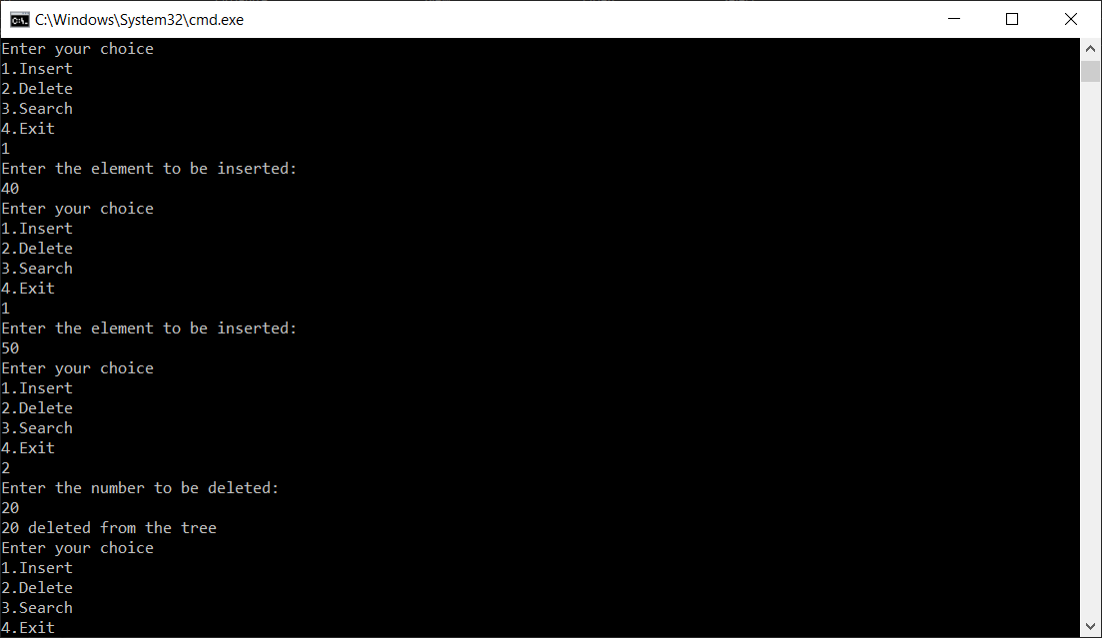

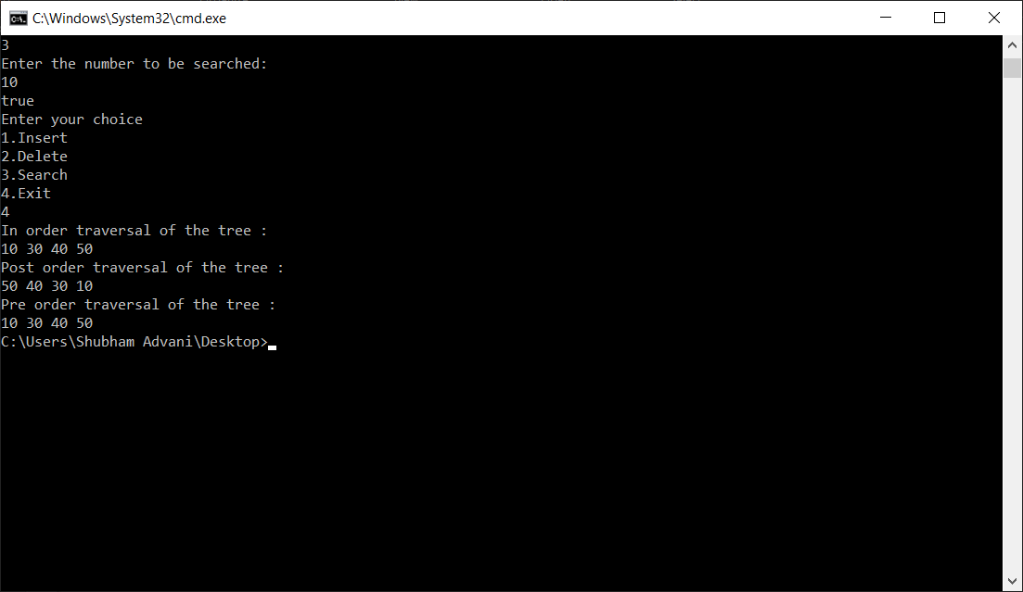

**CONCLUSION**

From the above practical, we learned about BST(Binary Search tree) and then take data from user and store it and display it in inorder, postorder and preorder.

**PRACTICAL - 10**

**AIM**

**Write a program that enters vertices, edges of a Graph and display sequence of vertices to traverse the graph in Depth First Search method.**

**PROGRAM CODE**

import java.util.*;

public class Hash_Key{

public static void main(String args[]) {

Random random=new Random();

long array[]=new long[20];

long temp;

int i,count=0,hk=0;

System.out.println("Data generated randomly:");

for (i = 0;; i++) {

if(count<20){

temp=(long)(Math.random()%10000000)*7;

if(temp>=100000&&temp<=999999){

hk=(int)temp%18+2;

System.out.println("Hash Key= "+hk+" -> \t "+temp);

if(array[hk]!=0){

while (array[hk]!=0) {

hk++;

if(hk>20){

hk=0;

}

}

array[hk]=temp;

}

else{

array[hk]=temp;

count++;

}

}

}

else{

break; }

} }

}

**OUTPUT**

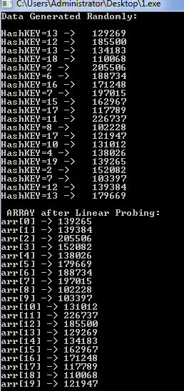

**CONCLUSION**

In this practical, we learnt how to use hash function to generate key and linear probing to avoid collision.

**PRACTICAL - 11**

**AIM**

**In an array of 20 elements, arrange 15 different values, which are generated randomly. Use hash function to generate key and linear probing to avoid collision. H(x) = (x mod 18) + 2. Write a program to input and display the final values of array.**

**11.1 PROGRAM CODE**

#include<stdio.h>

#include<stdlib.h>

/* to store a data (consisting of key and value) in hash table array */

struct item

{

int key;

int value;

};

/* each hash table item has a flag (status) and data (consisting of key and value) */

struct hashtable_item

{

int flag;

/*

* flag = 0 : data does not exist

* flag = 1 : data exists

* flag = 2 : data existed at least once

*/

struct item *data;

};

struct hashtable_item *array;

int size = 0;

int max = 10;

/* initializing hash table array */

void init_array()

{

int i;

for (i = 0; i < max; i++)

{

array[i].flag = 0;

array[i].data = NULL;

}

}

/* to every key, it will generate a corresponding index */

int hashcode(int key)

{

return (key % max);

}

/* to insert an element in the hash table */

void insert(int key, int value)

{

int index = hashcode(key);

int i = index;

/* creating new item to insert in the hash table array */

struct item *new_item = (struct item*) malloc(sizeof(struct item));

new_item->key = key;

new_item->value = value;

/* probing through the array until we reach an empty space */

while (array[i].flag == 1)

{

if (array[i].data->key == key)

{

/* case where already existing key matches the given key */

printf("\n Key already exists, hence updating its value \n");

array[i].data->value = value;

return;

}

i = (i + 1) % max;

if (i == index)

{

printf("\n Hash table is full, cannot insert any more item \n");

return;

}

}

array[i].flag = 1;

array[i].data = new_item;

size++;

printf("\n Key (%d) has been inserted \n", key);

}

/* to remove an element from the hash table */

void remove_element(int key)

{

int index = hashcode(key);

int i = index;

/* probing through array until we reach an empty space where not even once an element had been present */

while (array[i].flag != 0)

{

if (array[i].flag == 1 && array[i].data->key == key )

{

// case when data key matches the given key

array[i].flag = 2;

array[i].data = NULL;

size--;

printf("\n Key (%d) has been removed \n", key);

return;

}

i = (i + 1) % max;

if (i == index)

{

break;

}

}

printf("\n This key does not exist \n");

}

/* to display all the elements of hash table */

void display()

{

int i;

for (i = 0; i < max; i++)

{

struct item *current = (struct item*) array[i].data;

if (current == NULL)

{

printf("\n Array[%d] has no elements \n", i);

}

else

{

printf("\n Array[%d] has elements -: \n %d (key) and %d(value) ", i, current->key, current->value);

}

}

}

int size_of_hashtable()

{

return size;

}

void main()

{

int choice, key, value, n, c;

array = (struct hashtable_item*) malloc(max * sizeof(struct hashtable_item*));

init_array();

do {

printf("Implementation of Hash Table in C with Linear Probing \n\n");

printf("MENU-: \n1.Inserting item in the Hashtable"

"\n2.Removing item from the Hashtable"

"\n3.Check the size of Hashtable"

"\n4.Display Hashtable"

"\n\n Please enter your choice-:");

scanf("%d", &choice);

switch(choice)

{

case 1:

printf("Inserting element in Hashtable\n");

printf("Enter key and value-:\t");

scanf("%d %d", &key, &value);

insert(key, value);

break;

case 2:

printf("Deleting in Hashtable \n Enter the key to delete-:");

scanf("%d", &key);

remove_element(key);

break;

case 3:

n = size_of_hashtable();

printf("Size of Hashtable is-:%d\n", n);

break;

case 4:

display();

break;

default:

printf("Wrong Input\n");

}

printf("\n Do you want to continue-:(press 1 for yes)\t");

scanf("%d", &c);

}while(c == 1);

getch();

}

**OUTPUT**

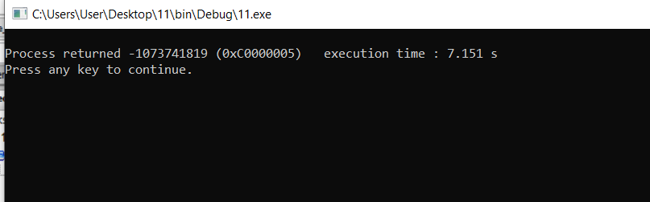

**11.2 PROGRAM CODE**

#include <stdio.h>

int main()

{

int a[1000],i,n;

printf("Enter size of array: ");

scanf("%d",&n);

printf("Enter %d elements in the array : ", n);

for(i=0;i<n;i++)

{

scanf("%d", &a[i]);

}

printf("\nElements in array are: ");

for(i=0;i<n;i++)

{

printf("%d ", a[i]);

}

return 0;

}

**OUTPUT**

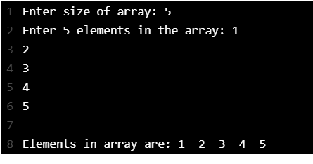

**CONCLUSION**

In this practical, we learnt hash function to generate key and linear probing to avoid collision and to input and display the final values of array.